FOR IMMEDIATE RELEASE: March 2013

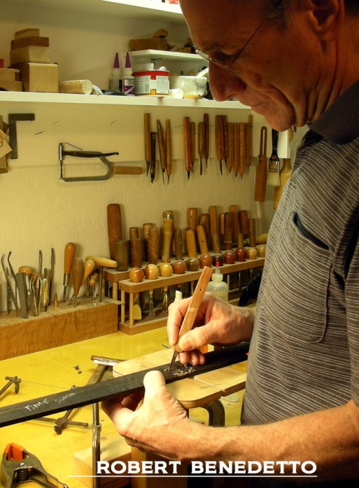
Robert Benedetto inlays the fingerboard of his 45th Anniversary guitar in 2013

Benedetto Guitars Celebrates 45 Years (1968-2013)

Founded in 1968 by American luthier Robert Benedetto, Benedetto Guitars, Inc. of Savannah, Georgia is celebrating 2013 as their 45th Anniversary of jazz guitar excellence. The small but internationally renowned company builds some of the world’s most collectable and expensive instruments while still focusing their production on the needs of professional and aspiring jazz guitarists.

Benedetto guitars have been played by three generations of jazz masters including Johnny Smith, Kenny Burrell, Bucky Pizzarelli, Martin Taylor, and Pat Martino as well as Howard Alden, Dan Faehnle, Jack Wilkins, Ron Eschete, Frank Vignola, Chico Pinheiro, Jimmy Bruno, Earl Klugh, Andreas Varady and many others. The Benedetto guitar appears on countless recordings, videos, and TV and film soundtracks, and has been featured in books, magazines and museums (including the permanent collection of The Smithsonian Institution’s National Museum of American History), and on concert stages and jazz festivals around the world.

Born in the Bronx, New York in 1946, Benedetto’s great American journey has taken him from his personal workbench as an independent luthier, through prominence as author of the highly acclaimed 1994 publication “Making An Archtop Guitar,” to overseeing construction via licensing agreements at Fender & Guild guitar companies, to chairmanship of his own Benedetto Guitars, Inc. manufacturing company.

President/CEO of Benedetto Guitars Howard Paul notes that “Bob’s unparalleled career has impacted the entire industry, and raised the bar for luthiers, manufacturers, and players alike. His 45 years of experience, experimentation, collaboration with the greatest players of their day, and willingness to share his secrets and know-how can be heard and felt in every Benedetto guitar made today, as they reflect Benedetto’s character and talent.”

To commemorate the occasion, a one-of-a-kind 45th Anniversary guitar is being made.
"Bob Benedetto is the foremost builder of archtop guitars in the world. With tools that had belonged to his grandfather and tools that he made himself, he started making guitars entirely by hand. He rose to become the standard bearer of a tradition of hand craftsmanship that threads its way back through the work of John D¹Angelico, Orville Gibson, Lloyd Loar and even further to the centuries-old reverence for artistry and craft that is so much a part of the Italian and Italian-American heritage." TOM WHEELER, Renowned Guitar Historian, Author of The Guitar Book; American Guitars; The Stratocaster Chronicles; former Editor in Chief, Guitar Player Magazine

www.benedettoguitars.com

Benedetto Guitars, 10 Mall Terrace, Suite A, Savannah GA 31406 USA

